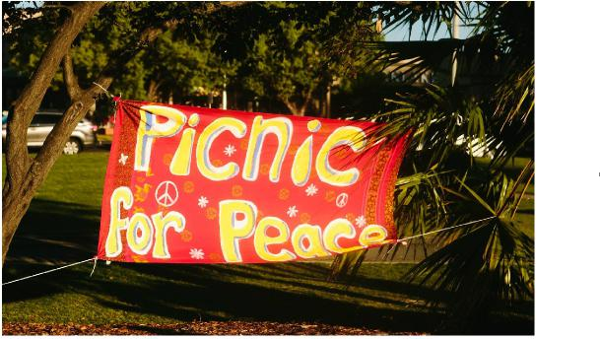

**PICNIC 4 PEACE**

**membership form**

**Individual $5 or Family $10**

**Please circle**

**Picnic for Peace fosters peace and hope, friendship and unity.   
Picnic 4 Peace was born in November of 2015 at Victoria Park Lake,   
Shepparton gathering people together   
who have a common hope of Peace in the world.   
We continue with other picnics and World Peace Day events.**

**Your membership and financial support assists us to bring**

**Picnic 4 Peace events to the community.**

**Thank you for your commitment and involvement.**

**Name(s): _____________________________________________**

**Postal Address:**

**Phone:**

**Email:**

**Date membership began:**

**Office use only:**

**Annual membership received. Date**

**Signed: Position _____________**